MATH 324 Homework 7

Mehmet Arslan

4/1/2021

**Problem 1**

x = c(19, 31, 34, 35, 39, 39, 43)  
y = c(410, 580, 590, 570, 640, 680, 660)  
  
plot(x, y, xlab = "Fat Content",  
 ylab = "Calories")

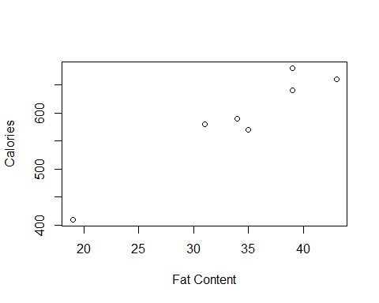

lspeed <- lm(y~x)  
summary(lspeed)

##   
## Call:  
## lm(formula = y ~ x)  
##   
## Residuals:  
## 1 2 3 4 5 6 7   
## -11.009 26.325 3.159 -27.897 -2.119 37.881 -26.341   
##   
## Coefficients:  
## Estimate Std. Error t value Pr(>|t|)   
## (Intercept) 210.95 50.10 4.211 0.008404 **   
## x 11.06 1.43 7.732 0.000578 ***  
## ---  
## Signif. codes: 0 '***' 0.001 '**' 0.01 '*' 0.05 '.' 0.1 ' ' 1  
##   
## Residual standard error: 27.33 on 5 degrees of freedom  
## Multiple R-squared: 0.9228, Adjusted R-squared: 0.9074   
## F-statistic: 59.78 on 1 and 5 DF, p-value: 0.0005782

**Problem 2**

plot(x, y, xlab = "Fat Content",   
 ylab = "Calories") +   
abline(lspeed, col = "red")

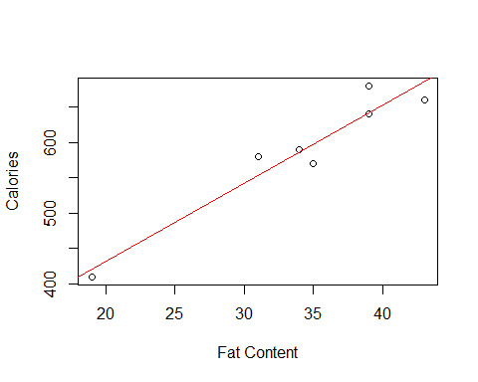

## integer(0)

**Problem 3**

qt(1.95/2, df = 5) #pulled the values from the summary of lspeed.

## [1] 2.570582

b_0 = 210.954  
SE_b_0 = 2.571*(50.10)  
  
b_1 = 11.056  
SE_b_1 = 2.571*(1.43)

**Problem 6**

#what would you estimate calorie count to be when x = 30? When x = 40?   
  
predict(lspeed, data.frame(x = 30), level = 0.99, interval = "p", se = T)

## $fit  
## fit lwr upr  
## 1 542.6192 422.2319 663.0065  
##   
## $se.fit  
## [1] 12.01202  
##   
## $df  
## [1] 5  
##   
## $residual.scale  
## [1] 27.33398

predict(lspeed, data.frame(x = 40), level = 0.99, interval = "p", se = T)

## $fit  
## fit lwr upr  
## 1 653.1744 530.8307 775.518  
##   
## $se.fit  
## [1] 13.17182  
##   
## $df  
## [1] 5  
##   
## $residual.scale  
## [1] 27.33398

**Problem 7**

est_sig = (27.33)^2

**Problem 8**

predict(lspeed, data.frame(x = 32), level = 0.95, interval = "c", se = T)

## $fit  
## fit lwr upr  
## 1 564.7303 536.8757 592.5849  
##   
## $se.fit  
## [1] 10.83591  
##   
## $df  
## [1] 5  
##   
## $residual.scale  
## [1] 27.33398

predict(lspeed, data.frame(x = 38), level = 0.99, interval = "p", se = T)

## $fit  
## fit lwr upr  
## 1 631.0633 511.3088 750.8179  
##   
## $se.fit  
## [1] 11.61645  
##   
## $df  
## [1] 5  
##   
## $residual.scale  
## [1] 27.33398